**Sample Data used for these Test Cases:**

**Employee Data:**

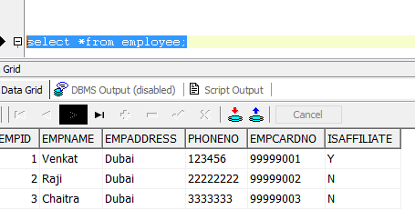

**Items in the Store:**

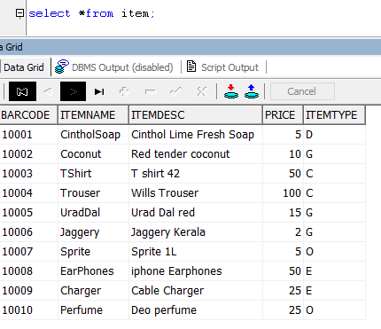

**Customer Information:**

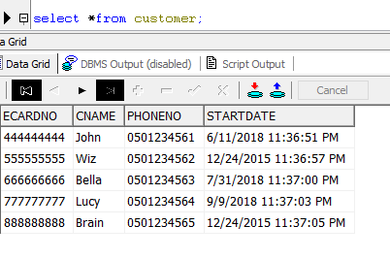

**Test Case #1: If the customer is an employee:** Discount 30%

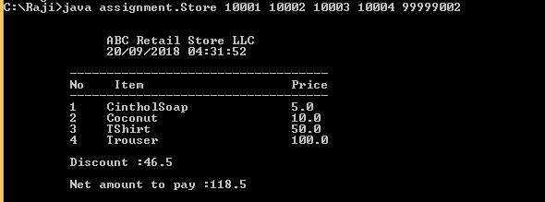

**Test Case #2: If the customer is an Affiliate:** Discount 10%

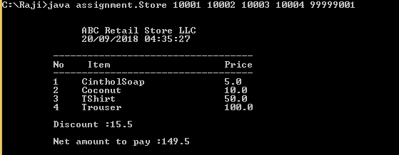

**Test Case #3: If the customer is 2 or more years old:** Discount 5%

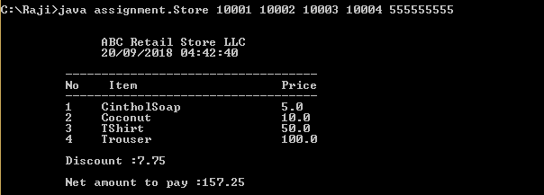

**Test Case #4: If the customer is less than 2 year old:** If the bill is 100 or more then discount is

5 AED/100

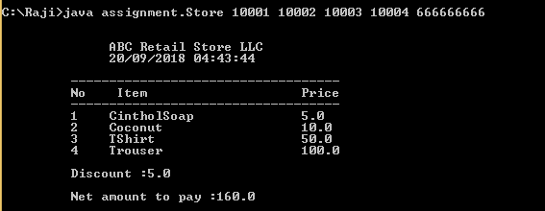

**Test Case #5: If the customer is Normal user and bill amount is less than 100:**  No Discount

